TEMPLATE 1 - Lead Magnet

HEADLINE - Elevator Speech Template
Pull Question: Ready to create a super engaged, high-vibe community for you & your brand

3 Bullets
This template shows you:
- A simple 4-step process to craft an attention-getting name
- How to boost interest in your signature speech, so you grow your audience
- A fun way to find the perfect combination of words, so the process is easy and quick

Button Copy
Give Me My Template Now!

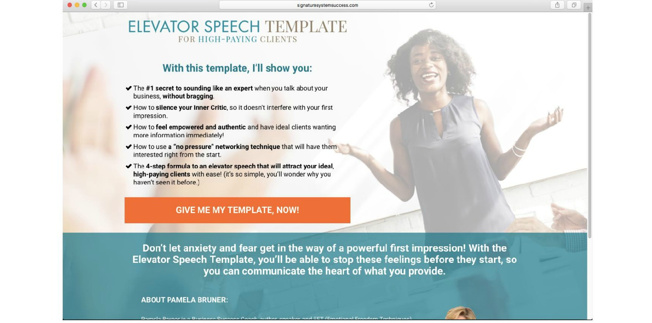

Your Headline:

Your Pull Question:

Your 3 Bullets:

Button Copy:

Page break Between Template 1 and Template 2

TEMPLATE 2 - Lead Magnet

HEADLINE - The Smart Girl’s Guide to Facebook Groups
Pull Question: Ready to create a super engaged, high-vibe community for you & your brand?

Button Copy
I’m ready!

Testimonials

Bio



TEMPLATE 3 - Lead Magnet

Headline: Tapping to Double Your Income

Here’s what you’ll get: Free Video Series

3 or 4 bullets
- Clear Limiting Beliefs…
- Remove the blocks..
- Remove the inner conflict…
- Be totally comfortable…

Button Copy
Send me the Free Video Series!

Example:
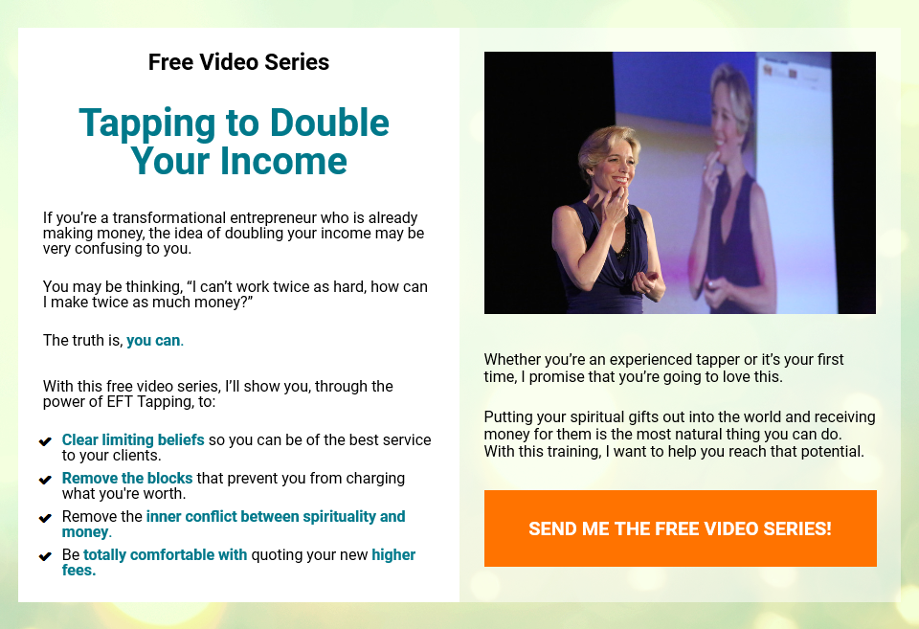

Your Headline:

Your 3 Bullets:

Button Copy:

